Part 2: Acceptance testing using Cucumber/Gherkin (24 marks)

## Identify and describe at least one defect or missing feature that was identified when performing the acceptance testing above. (2 marks)

An error in the CommandFactory was found. The code that was implemented in Part 1 was checking if the Parameter List was not null, but it failed to check if the list was empty or not. This would generate an index out of bounds exception if an empty List was supplied.

## Discuss some refactoring (include before and after code snippets) identified during acceptance testing that would improve your design. (2 marks)

To fix the bug which was found in the previous question and additional condition was added to the existing check, which makes sure that the list must be supplied with at least 1 element, which should be the name of the command.

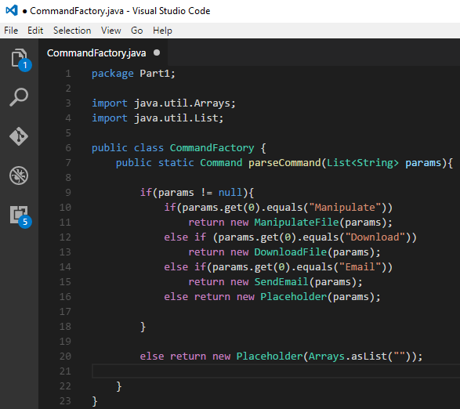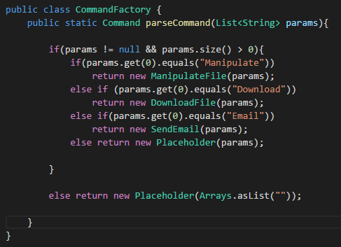

## Explain the importance Cucumber/Gherkin in the process of test driven development, using your experience in this project or other work you did during the semester. (3 marks)

One of the best benefits that Cucumber or Gherkin should offer, is that these tests can be understood by non-technical individuals which may be key stake holders in the project. Having said that, if non-technical key stake holders are involved in testing phases such as this, the project being developed will be closer to the user expectations.